

Proposed $80M megamansion hits market as Fort Lauderdale’s priciest listing
Offering pairs $30M development site with plans for 20,000-square-foot manor aimed at billionaire tastes
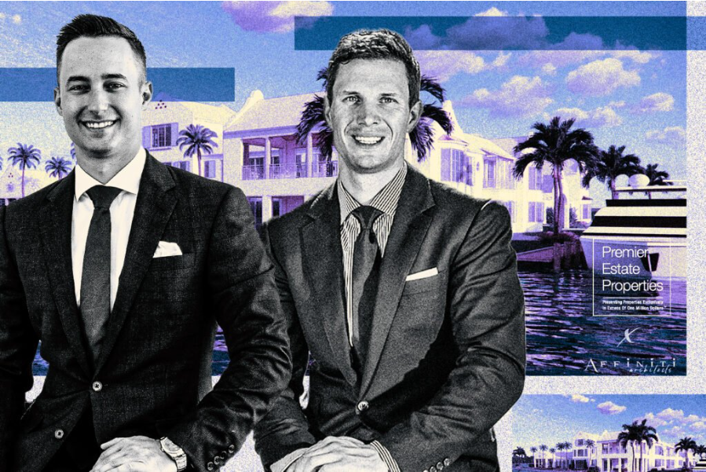
Premier Estate Properties' Kevin Kreutzfeld and Platon Polishchuk with 1000 Riviera Isle Drive (Affiniti Architects & Premier Estate Properties)
Jul 24, 2026, 2:00 PM EDT
By Grace McClung
A proposed trophy estate in Fort Lauderdale hit the market for $80 million, making it the city’s priciest residential listing, according to the listing agents.
The property includes a 1.2-acre waterfront site at 1000 Riviera Isle Drive, asking $30 million, along with plans for The Manor at Banyan Point, a 20,000-square-foot mansion. If completed as designed, the estate would be priced at $4,000 per square foot.
Kevin Kreutzfeld and Platon Polishchuk of Premier Estate Properties have the listing. Affiniti Architects designed the manor, and Mark Timothy Luxury Homes is the builder, according to the listing.
The Manor at Banyan Point proposal includes 10 bedrooms, 12 bathrooms and six half-baths. The plan calls for two carriage houses, two staff suites, a wellness center and a 10-car garage that can accommodate 20 cars with lifts.
The site has 520 feet of waterfrontage, including 300 feet of protected side dockage on the Rio Idlewyld Canal.
Kreutzfeld said the manor is designed with billionaires in mind.

The project aims to rival the “world-class estates” in Palm Beach, Miami and the Hamptons, he said. Fort Lauderdale’s luxury market historically has lagged behind its neighbors, but recent record-breaking listings and billionaire activity are narrowing the gap.
Last month, Prestige Homes Development founder and CEO Dov Stark listed a new waterfront estate in Fort Lauderdale’s Sunrise Intracoastal neighborhood for $55 million, setting the record for Broward County’s highest-priced residential listing, The Real Deal previously reported.
Earlier this year, billionaire WeatherTech founder David MacNeil sold his Fort Lauderdale mansion for $26 million. Other billionaires who own or have owned property in the city include former Oracle CEO Safra Catz, GQG Partners co-founder and chairman Rajiv Jain and the late businessman H. Wayne Huizenga.
Nicknamed the “Venice of America” for its canals and boating culture, Fort Lauderdale’s luxury market is dominated by waterfront real estate. The city is attracting an influx of out-of-state buyers seeking prime land on the water and a laidback lifestyle compared to Miami or Palm Beach. While luxury sales have rebounded following the pandemic, market insiders are cautious as they watch for a possible oversupply.
Companies and People
OraclePremier Estate PropertiesThe Real Deal

